

**Instituto Tecnológico y de Estudios Superiores de Monterrey**

**Campus Queretaro**

**Semestre Agosto - Diciembre 2023**

**Actividad 5 (Extracción de Características)**

**Alumno:**

Julio Emilio Bautista Tapia | A01367978

15 de Octubre del 2023

# Análisis para la variable categórica: _updated_by

|  |  |  |
| --- | --- | --- |
| Categoría | Frecuencia | Porcentaje |
| 20.0 | 0.11695906432748537 | 0.11695906432748543 |
| 16.0 | 0.0935672514619883 | 0.21052631578947376 |
| 14.0 | 0.08187134502923976 | 0.29239766081871355 |
| 13.0 | 0.07602339181286549 | 0.3684210526315791 |
| 13.0 | 0.07602339181286549 | 0.44444444444444464 |
| 12.0 | 0.07017543859649122 | 0.5146198830409359 |
| 9.0 | 0.05263157894736842 | 0.5672514619883042 |
| 8.0 | 0.04678362573099415 | 0.6140350877192984 |
| 7.0 | 0.04093567251461988 | 0.6549707602339184 |
| 7.0 | 0.04093567251461988 | 0.6959064327485384 |
| 6.0 | 0.03508771929824561 | 0.730994152046784 |
| 6.0 | 0.03508771929824561 | 0.7660818713450296 |
| 4.0 | 0.023391812865497075 | 0.7894736842105267 |
| 4.0 | 0.023391812865497075 | 0.8128654970760237 |
| 4.0 | 0.023391812865497075 | 0.8362573099415208 |
| 3.0 | 0.017543859649122806 | 0.8538011695906437 |
| 3.0 | 0.017543859649122806 | 0.8713450292397665 |
| 3.0 | 0.017543859649122806 | 0.8888888888888895 |
| 2.0 | 0.011695906432748537 | 0.900584795321638 |
| 2.0 | 0.011695906432748537 | 0.9122807017543866 |
| 2.0 | 0.011695906432748537 | 0.9239766081871351 |
| 2.0 | 0.011695906432748537 | 0.9356725146198837 |
| 2.0 | 0.011695906432748537 | 0.9473684210526322 |
| 2.0 | 0.011695906432748537 | 0.9590643274853807 |

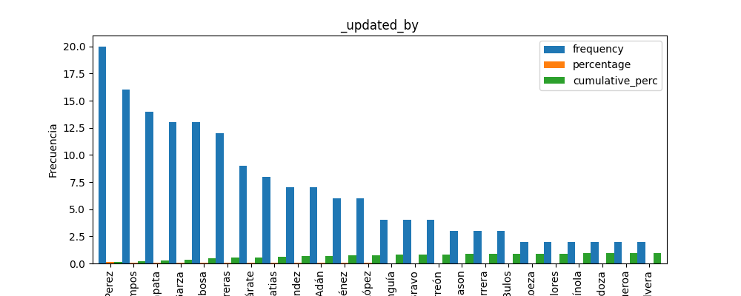

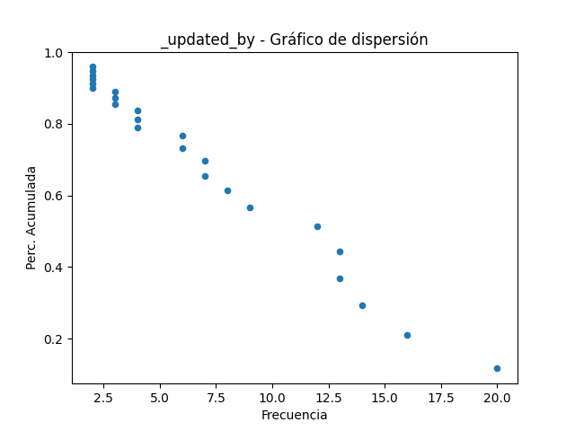

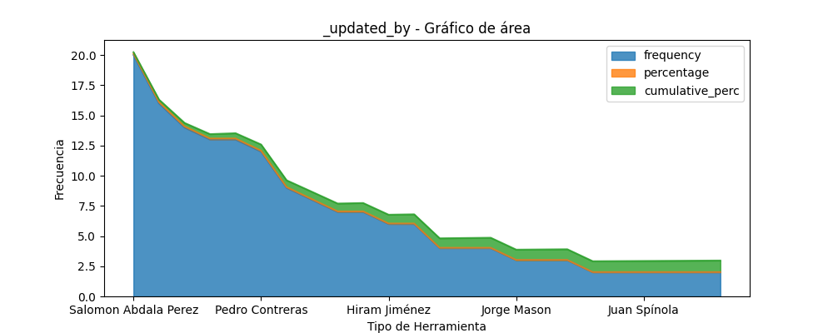

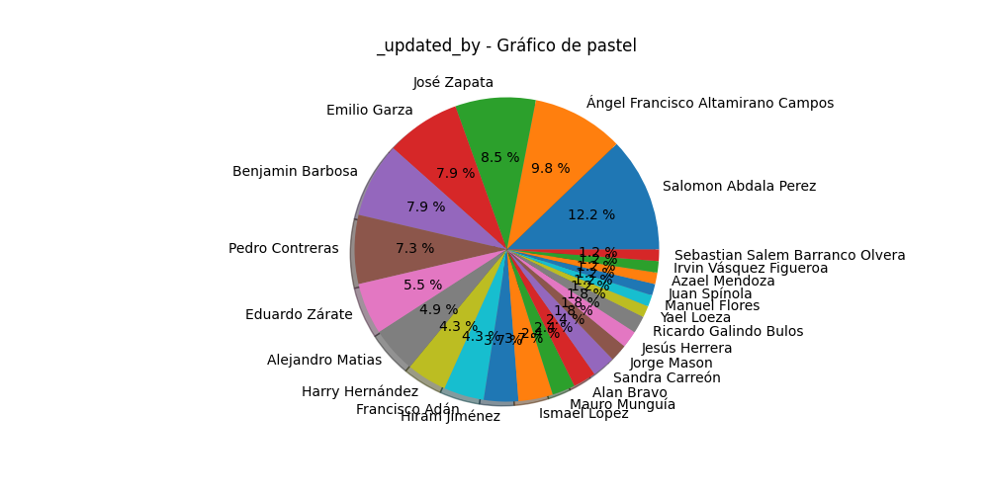

# Análisis para la variable categórica: 232_type_of_store

|  |  |  |
| --- | --- | --- |
| Categoría | Frecuencia | Porcentaje |
| 52.0 | 0.30409356725146197 | 0.30409356725146197 |
| 31.0 | 0.18128654970760233 | 0.4853801169590643 |
| 10.0 | 0.05847953216374269 | 0.5438596491228069 |
| 6.0 | 0.03508771929824561 | 0.5789473684210525 |
| 6.0 | 0.03508771929824561 | 0.6140350877192982 |
| 4.0 | 0.023391812865497075 | 0.6374269005847952 |
| 2.0 | 0.011695906432748537 | 0.6491228070175438 |
| 2.0 | 0.011695906432748537 | 0.6608187134502923 |
| 2.0 | 0.011695906432748537 | 0.6725146198830408 |
| 2.0 | 0.011695906432748537 | 0.6842105263157894 |

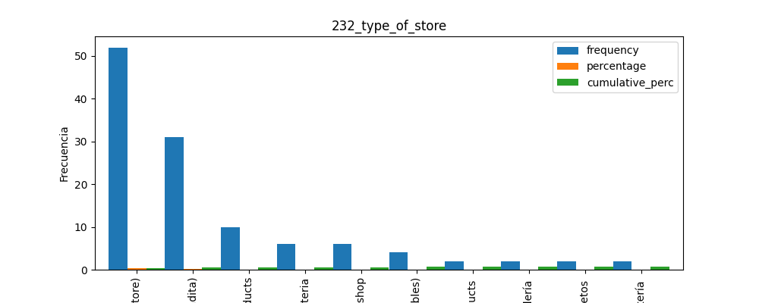

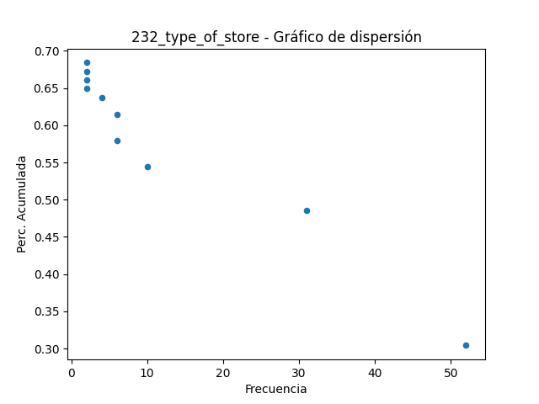

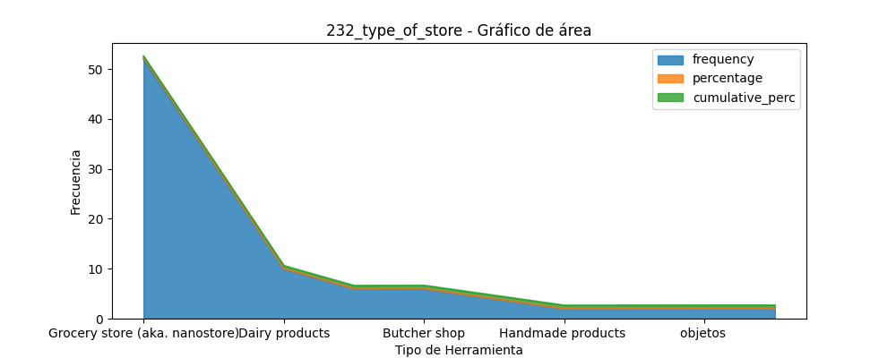

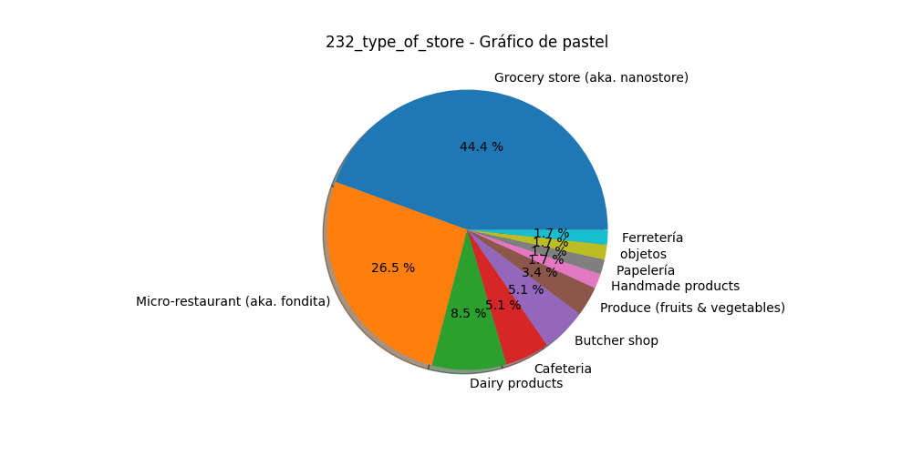

# Análisis para la variable categórica: 108_does_the_micro_retailer_has_a_barred_window_

|  |  |  |
| --- | --- | --- |
| Categoría | Frecuencia | Porcentaje |
| 124.0 | 0.7251461988304093 | 0.7251461988304093 |
| 47.0 | 0.27485380116959063 | 1.0 |

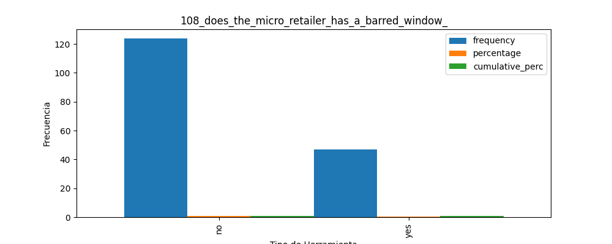

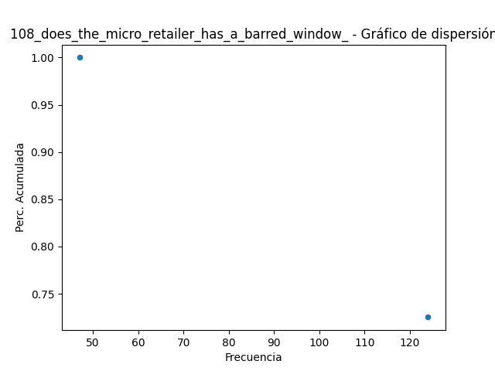

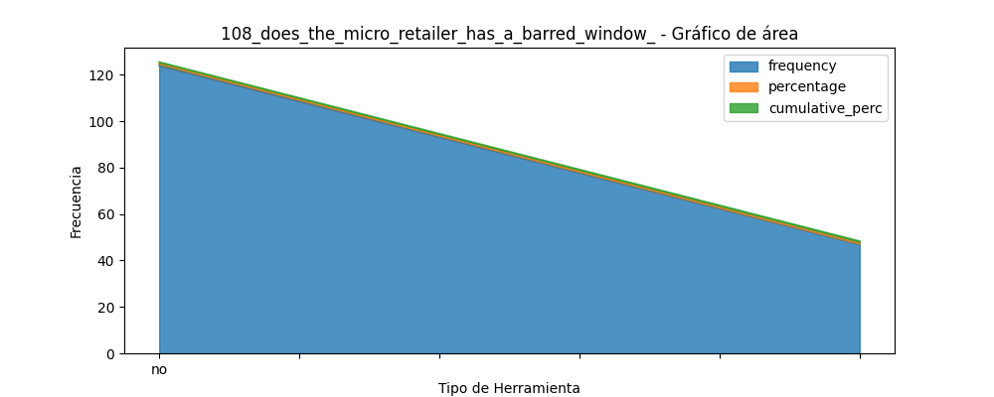

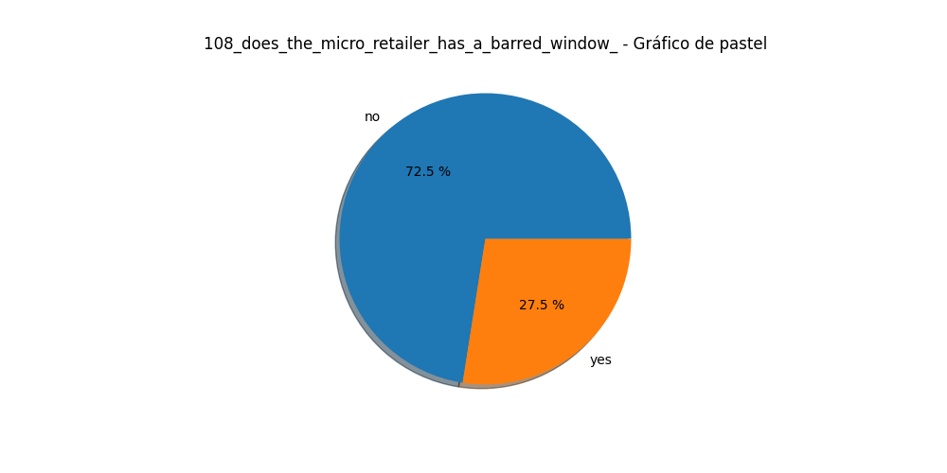

# Análisis para la variable categórica: 99_does_the_micro_retailer_exhibits_products_outside_

|  |  |  |
| --- | --- | --- |
| Categoría | Frecuencia | Porcentaje |
| 120.0 | 0.7017543859649122 | 0.7017543859649122 |
| 51.0 | 0.2982456140350877 | 1.0 |

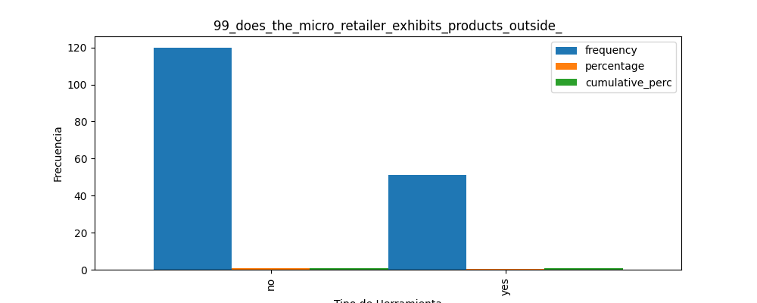

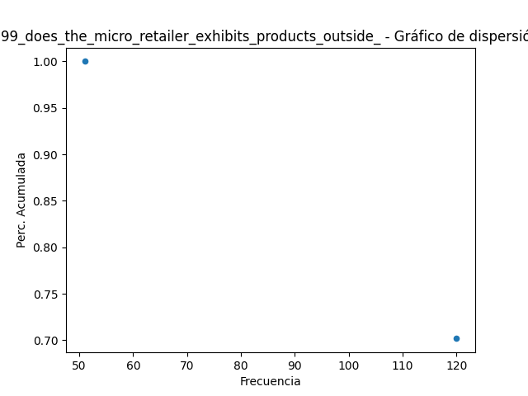

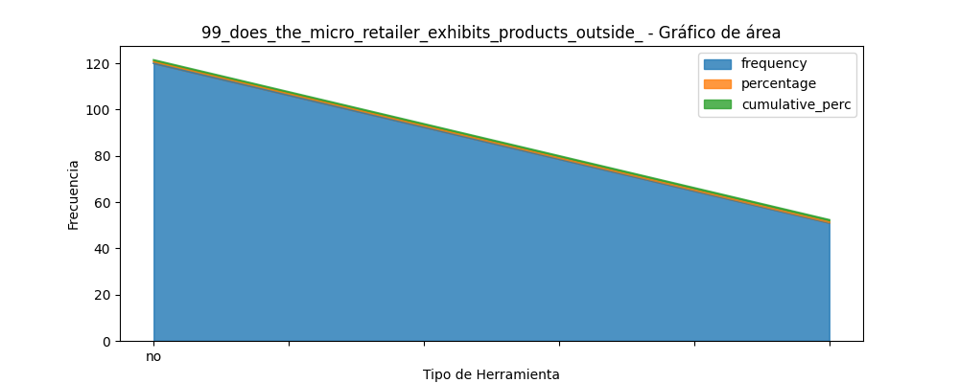

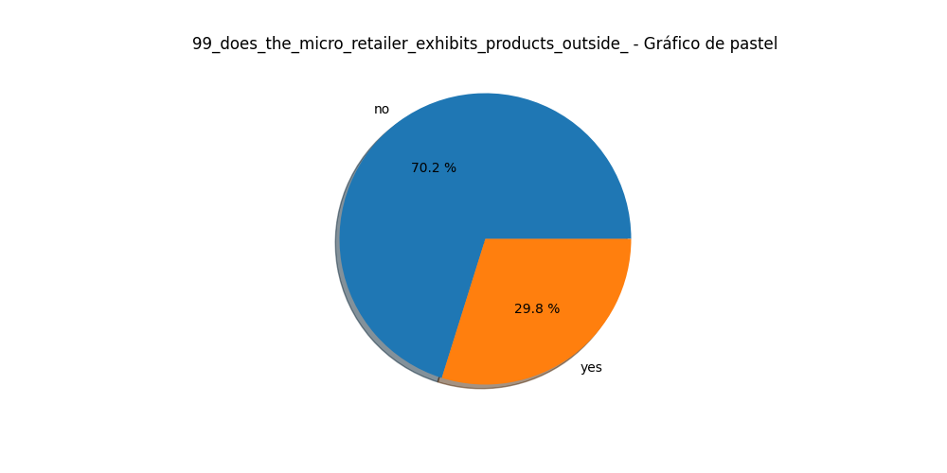

# Análisis para la variable categórica: 102_does_the_micro_retailer_sells_fresh_products_

|  |  |  |
| --- | --- | --- |
| Categoría | Frecuencia | Porcentaje |
| 105.0 | 0.6140350877192983 | 0.6140350877192983 |
| 66.0 | 0.38596491228070173 | 1.0 |

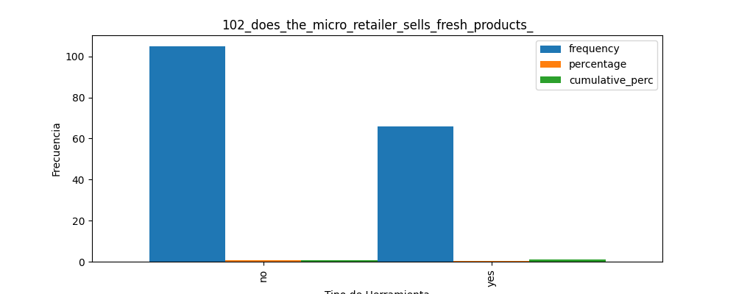

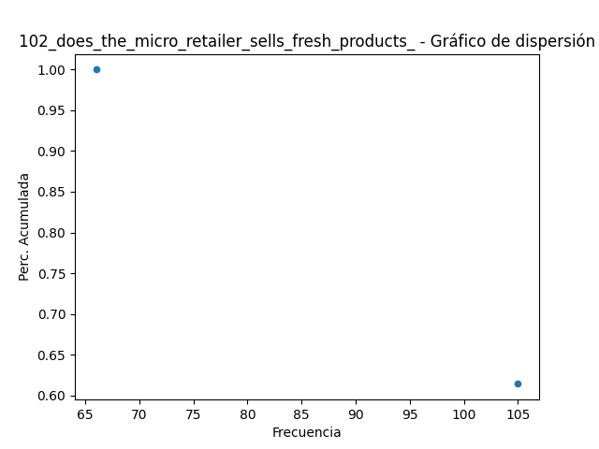

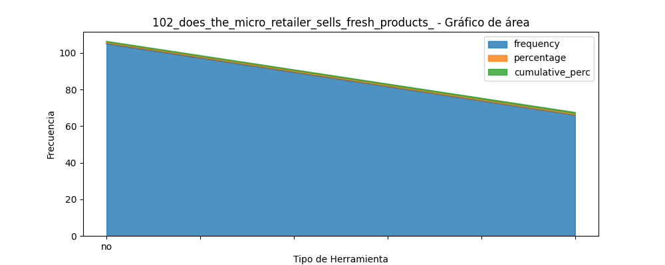

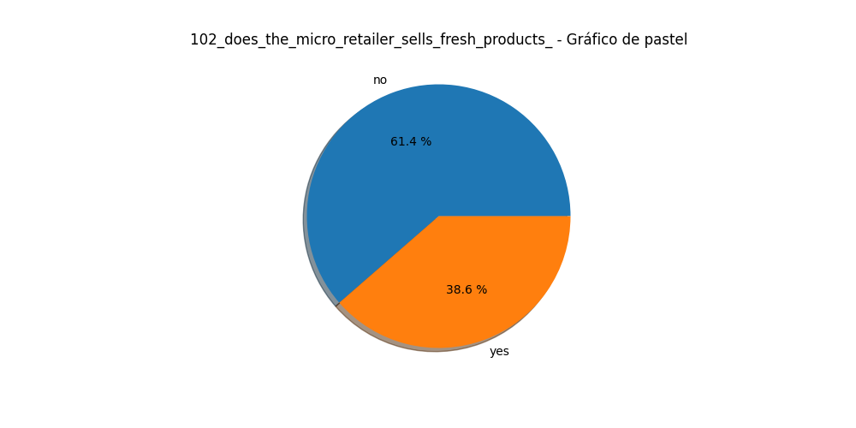

# Análisis para la variable categórica: 184_store_devices

|  |  |  |
| --- | --- | --- |
| Categoría | Frecuencia | Porcentaje |
| 52.0 | 0.30409356725146197 | 0.3040935672514621 |
| 16.0 | 0.0935672514619883 | 0.39766081871345044 |
| 9.0 | 0.05263157894736842 | 0.4502923976608189 |
| 9.0 | 0.05263157894736842 | 0.5029239766081873 |
| 8.0 | 0.04678362573099415 | 0.5497076023391815 |
| 7.0 | 0.04093567251461988 | 0.5906432748538013 |
| 5.0 | 0.029239766081871343 | 0.6198830409356726 |
| 5.0 | 0.029239766081871343 | 0.649122807017544 |
| 4.0 | 0.023391812865497075 | 0.6725146198830411 |
| 4.0 | 0.023391812865497075 | 0.6959064327485381 |
| 4.0 | 0.023391812865497075 | 0.7192982456140352 |
| 4.0 | 0.023391812865497075 | 0.7426900584795323 |
| 3.0 | 0.017543859649122806 | 0.7602339181286552 |
| 3.0 | 0.017543859649122806 | 0.777777777777778 |
| 3.0 | 0.017543859649122806 | 0.7953216374269009 |
| 3.0 | 0.017543859649122806 | 0.8128654970760237 |
| 3.0 | 0.017543859649122806 | 0.8304093567251466 |
| 2.0 | 0.011695906432748537 | 0.8421052631578951 |
| 2.0 | 0.011695906432748537 | 0.8538011695906437 |
| 2.0 | 0.011695906432748537 | 0.8654970760233922 |
| 2.0 | 0.011695906432748537 | 0.8771929824561409 |
| 2.0 | 0.011695906432748537 | 0.8888888888888894 |
| 2.0 | 0.011695906432748537 | 0.9005847953216379 |
| 2.0 | 0.011695906432748537 | 0.9122807017543865 |

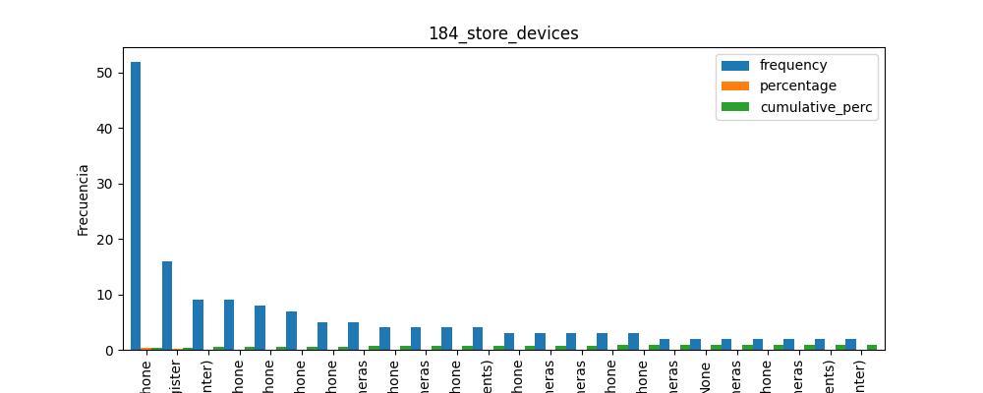

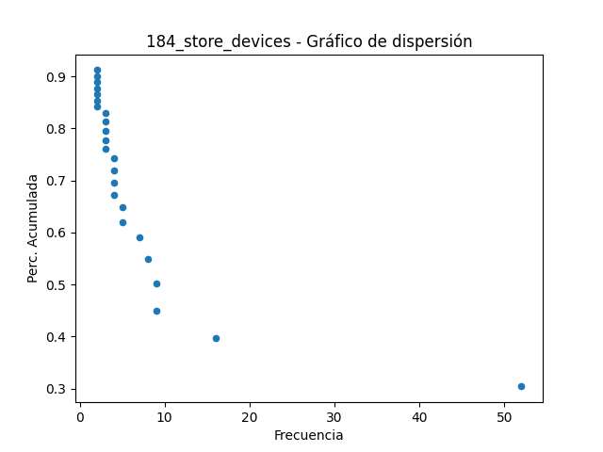

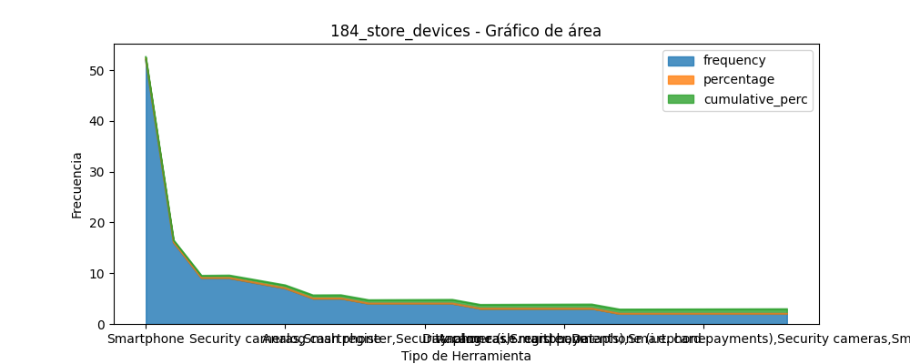

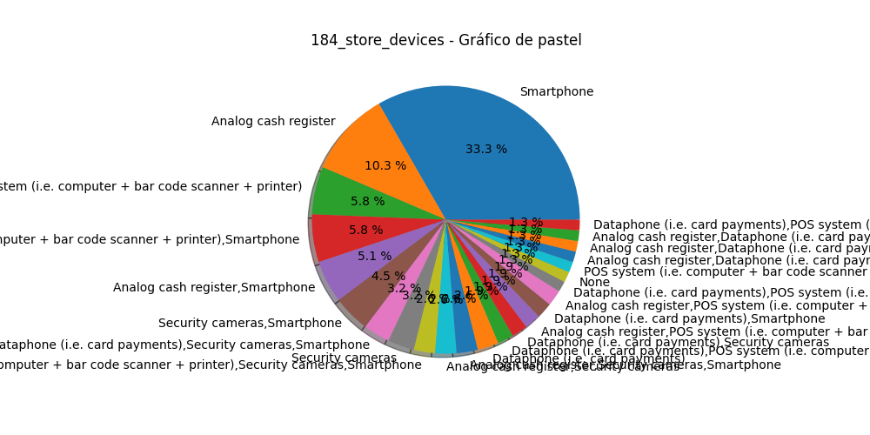

# Análisis para la variable categórica: hola_somos_estudiantes_del_tec_de_monterrey_estamos_realiz

|  |  |  |
| --- | --- | --- |
| Categoría | Frecuencia | Porcentaje |
| 113.0 | 0.6608187134502924 | 0.6608187134502924 |
| 58.0 | 0.3391812865497076 | 1.0 |

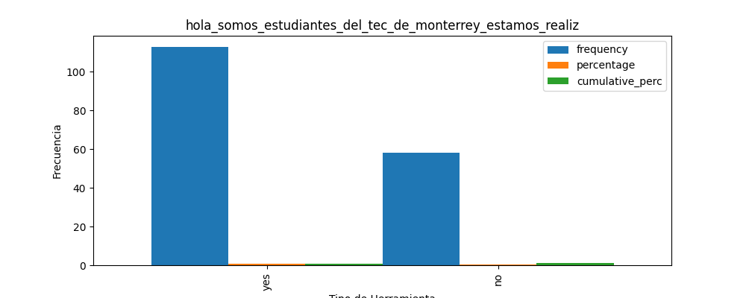

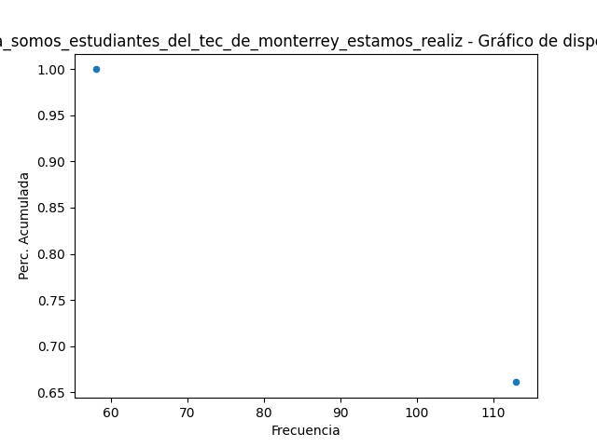

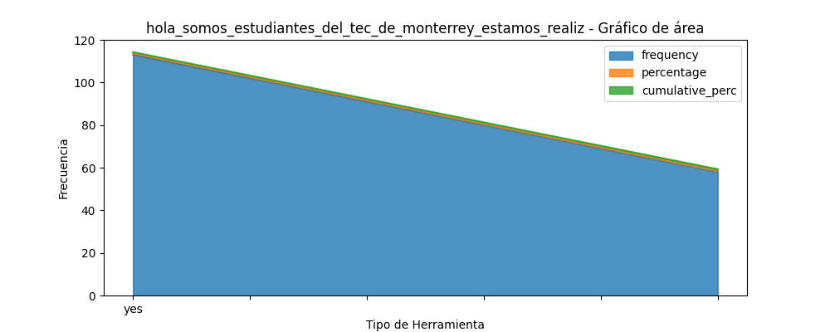

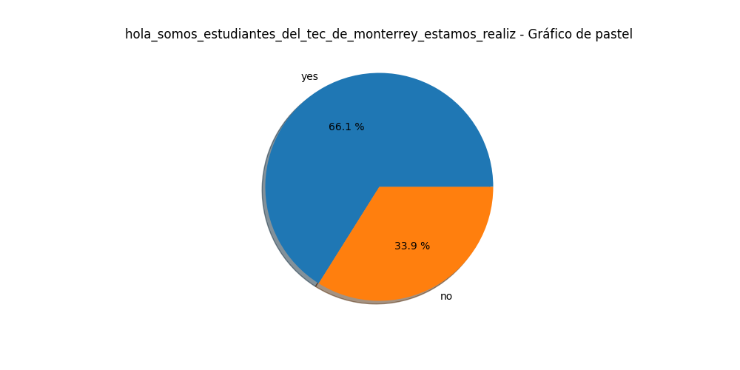

# Análisis para la variable categórica: le_comento_que_toda_esta_informacin_es_confidencial

|  |  |  |
| --- | --- | --- |
| Categoría | Frecuencia | Porcentaje |
| 164.0 | 0.9590643274853801 | 0.9590643274853801 |
| 7.0 | 0.04093567251461988 | 1.0 |

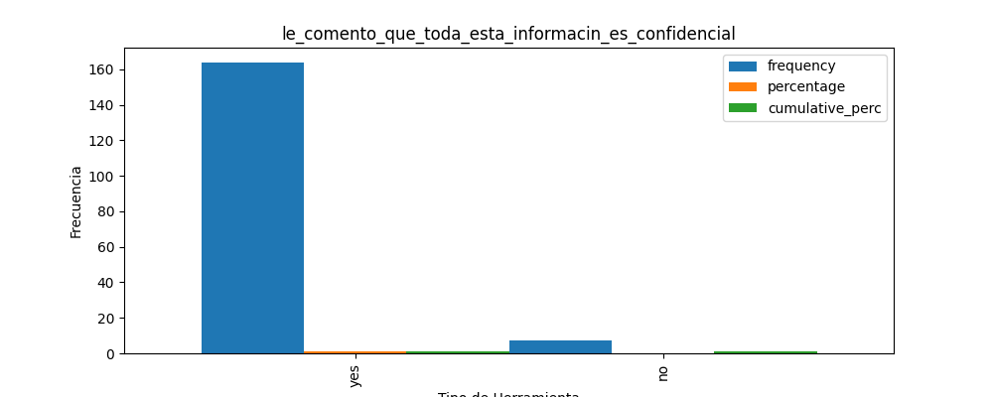

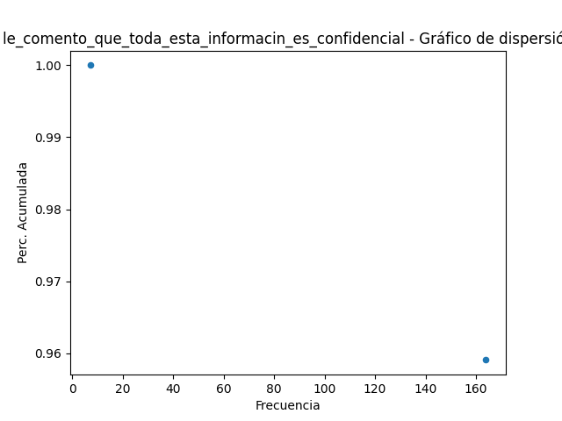

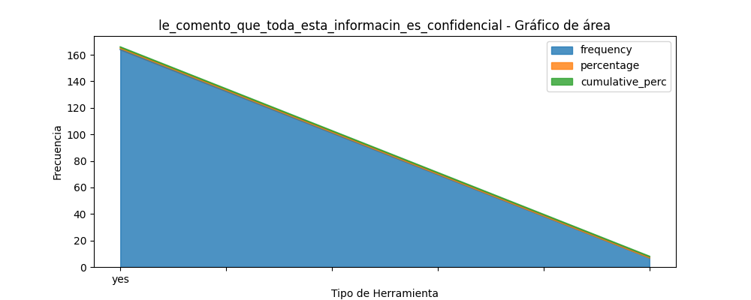

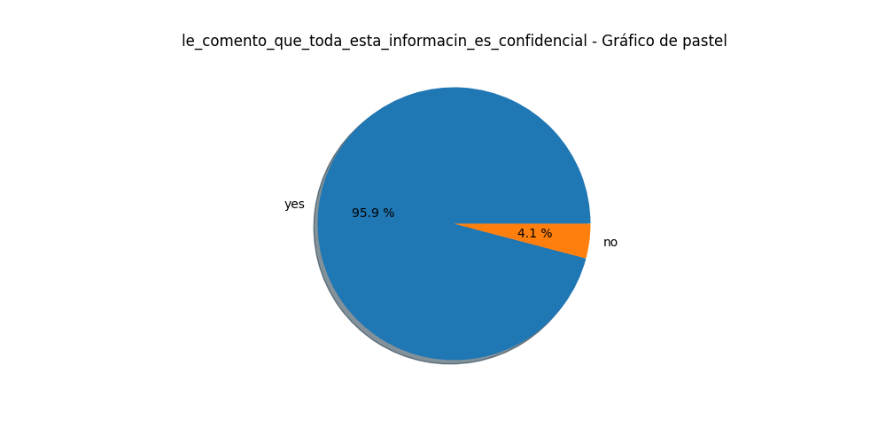

# Análisis para la variable categórica: 233_date_establishment

|  |  |  |
| --- | --- | --- |
| Categoría | Frecuencia | Porcentaje |
| 24.0 | 0.14035087719298245 | 0.14035087719298248 |
| 6.0 | 0.03508771929824561 | 0.1754385964912281 |
| 6.0 | 0.03508771929824561 | 0.2105263157894737 |
| 5.0 | 0.029239766081871343 | 0.23976608187134504 |
| 4.0 | 0.023391812865497075 | 0.26315789473684215 |
| 4.0 | 0.023391812865497075 | 0.2865497076023392 |
| 4.0 | 0.023391812865497075 | 0.3099415204678363 |
| 3.0 | 0.017543859649122806 | 0.3274853801169591 |
| 3.0 | 0.017543859649122806 | 0.3450292397660819 |
| 3.0 | 0.017543859649122806 | 0.3625730994152047 |
| 3.0 | 0.017543859649122806 | 0.3801169590643275 |
| 3.0 | 0.017543859649122806 | 0.3976608187134503 |
| 2.0 | 0.011695906432748537 | 0.40935672514619886 |
| 2.0 | 0.011695906432748537 | 0.4210526315789474 |
| 2.0 | 0.011695906432748537 | 0.43274853801169594 |
| 2.0 | 0.011695906432748537 | 0.4444444444444445 |
| 2.0 | 0.011695906432748537 | 0.456140350877193 |
| 2.0 | 0.011695906432748537 | 0.46783625730994155 |
| 2.0 | 0.011695906432748537 | 0.4795321637426901 |
| 2.0 | 0.011695906432748537 | 0.4912280701754386 |
| 2.0 | 0.011695906432748537 | 0.5029239766081872 |
| 2.0 | 0.011695906432748537 | 0.5146198830409358 |
| 2.0 | 0.011695906432748537 | 0.5263157894736843 |

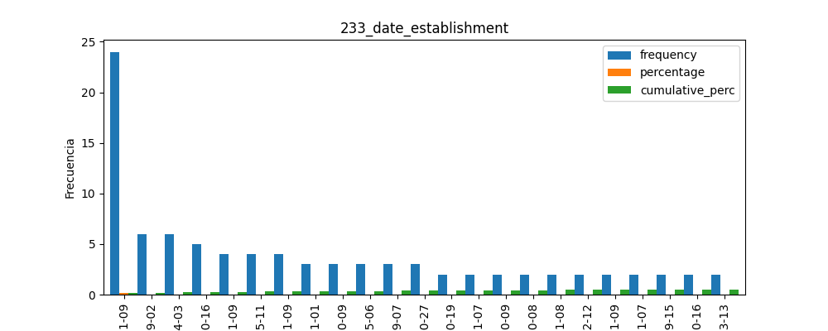

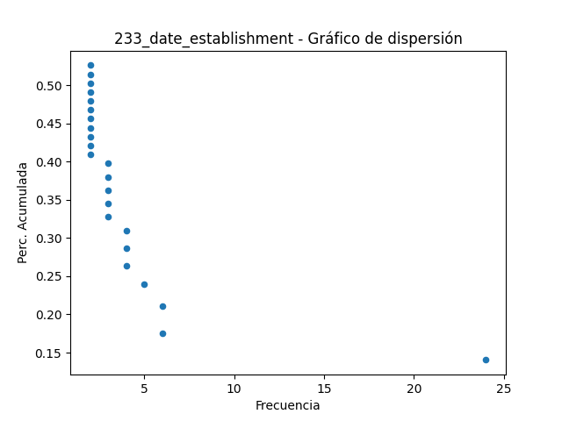

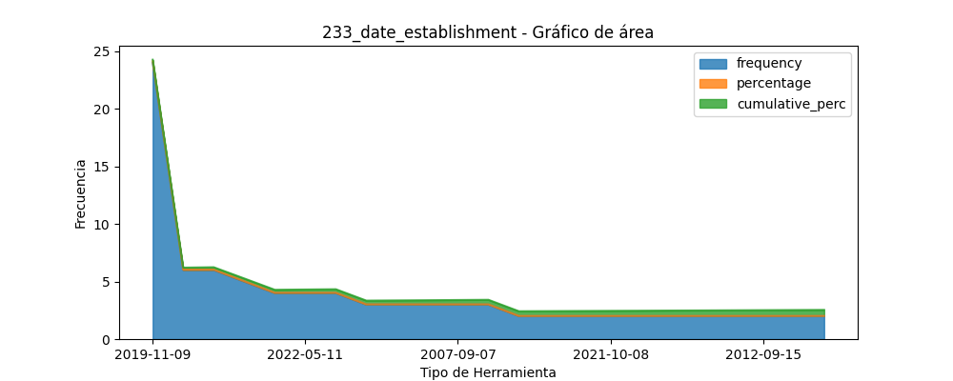

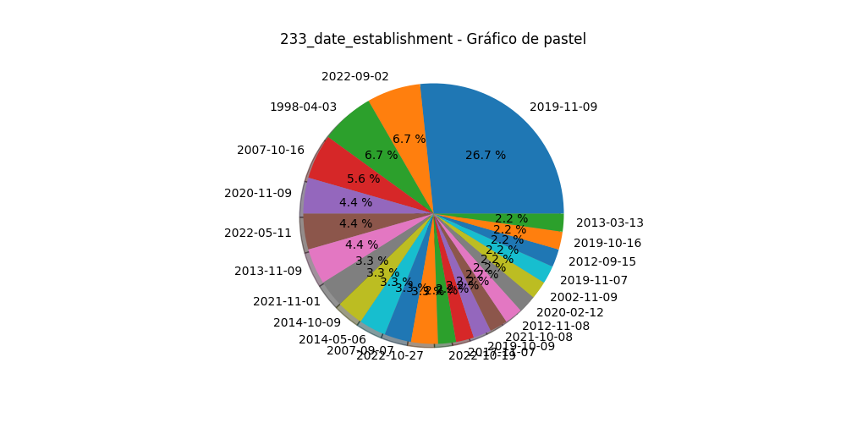

# Análisis para la variable categórica: 5_change_store_space_last_year

|  |  |  |
| --- | --- | --- |
| Categoría | Frecuencia | Porcentaje |
| 126.0 | 0.7368421052631579 | 0.7368421052631579 |
| 20.0 | 0.11695906432748537 | 0.8538011695906432 |
| 9.0 | 0.05263157894736842 | 0.9064327485380117 |
| 7.0 | 0.04093567251461988 | 0.9473684210526316 |
| 4.0 | 0.023391812865497075 | 0.9707602339181287 |
| 3.0 | 0.017543859649122806 | 0.9883040935672516 |
| 2.0 | 0.011695906432748537 | 1.0 |

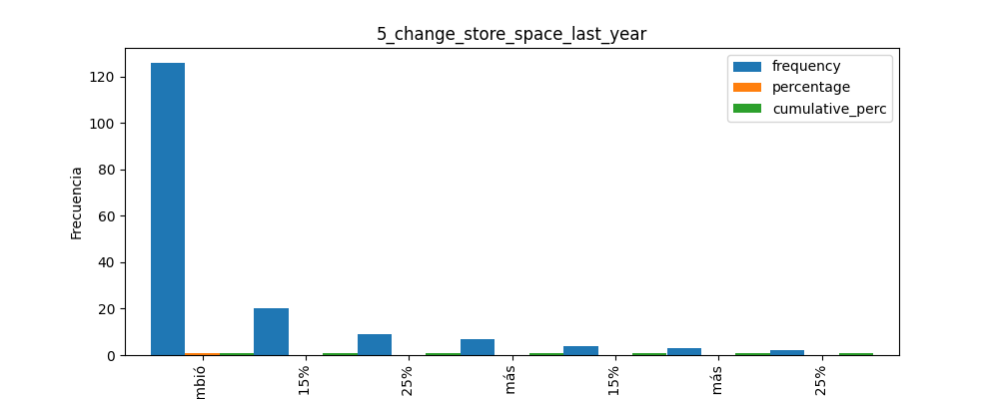

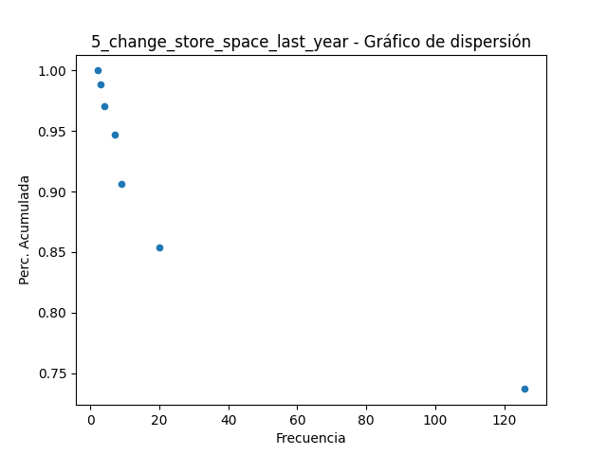

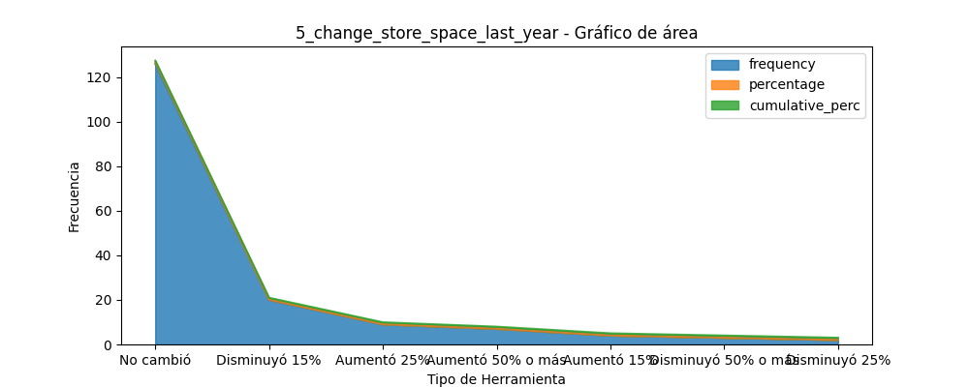

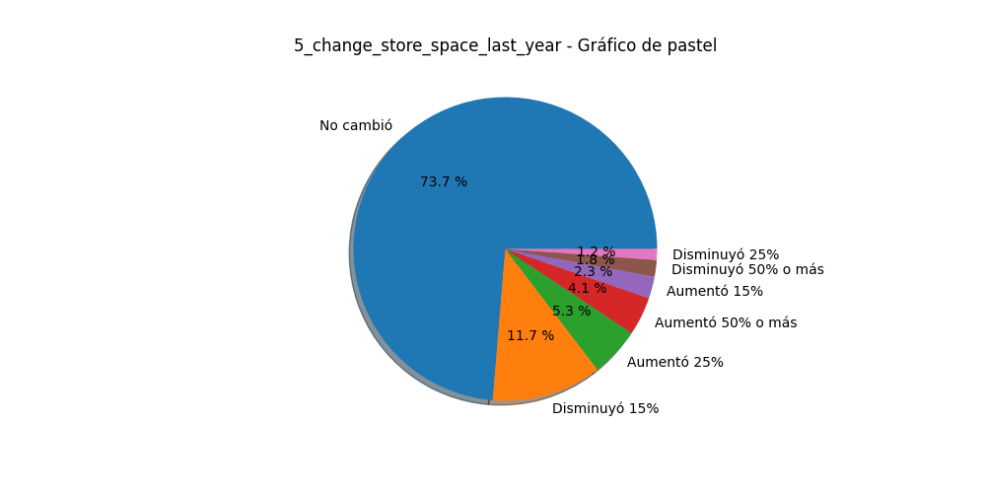

# Análisis para la variable categórica: 20_reviews_finances_monthly

|  |  |  |
| --- | --- | --- |
| Categoría | Frecuencia | Porcentaje |
| 130.0 | 0.7602339181286549 | 0.7602339181286549 |
| 41.0 | 0.23976608187134502 | 1.0 |

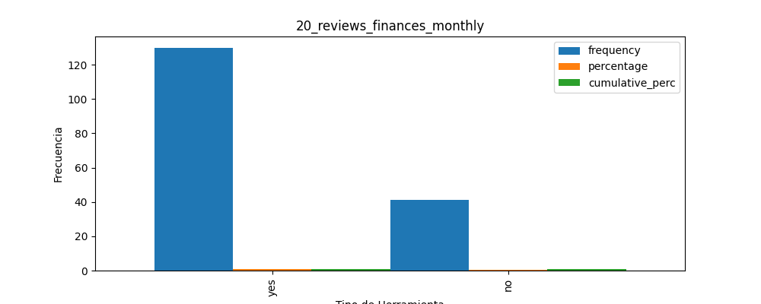

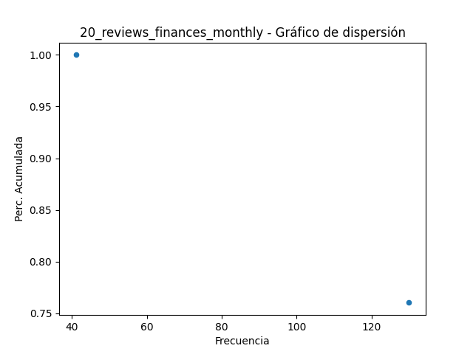

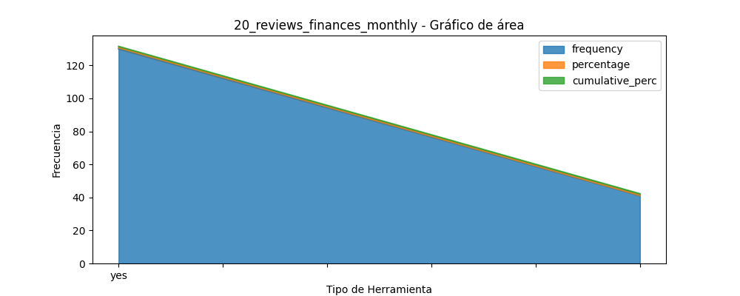

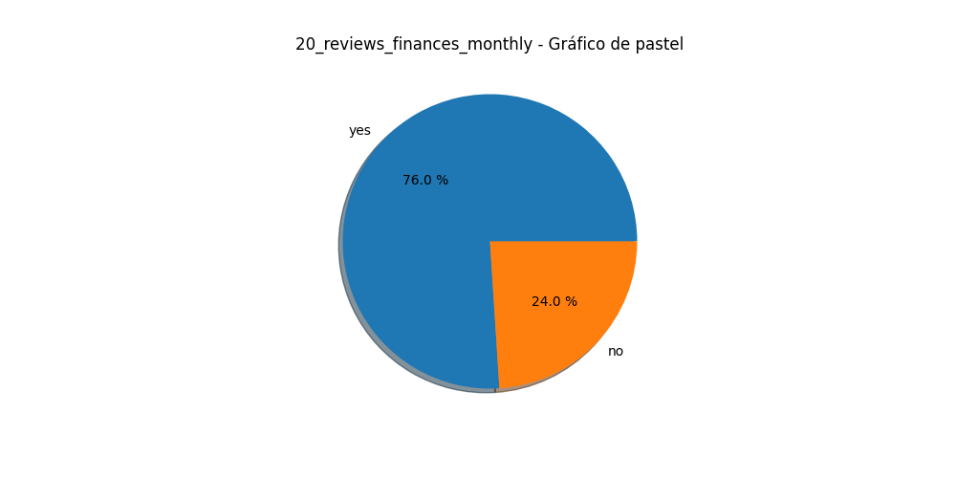

# Análisis para la variable categórica: 49_inventory_records

|  |  |  |
| --- | --- | --- |
| Categoría | Frecuencia | Porcentaje |
| 70.0 | 0.4093567251461988 | 0.4093567251461988 |
| 40.0 | 0.23391812865497075 | 0.6432748538011696 |
| 25.0 | 0.14619883040935672 | 0.7894736842105263 |
| 23.0 | 0.13450292397660818 | 0.9239766081871346 |
| 9.0 | 0.05263157894736842 | 0.9766081871345029 |

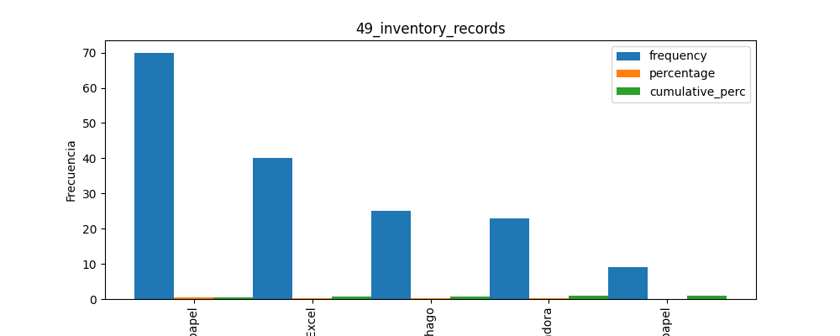

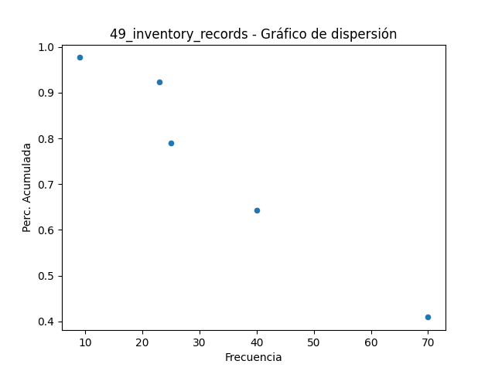

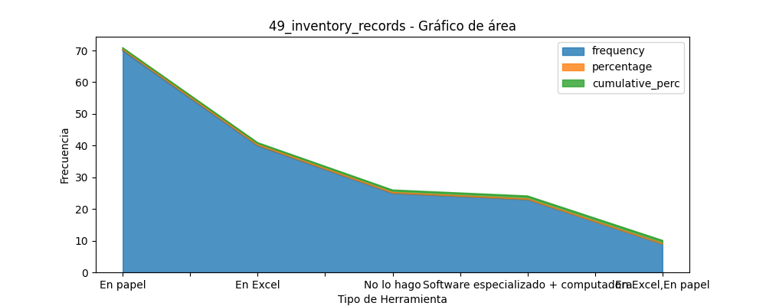

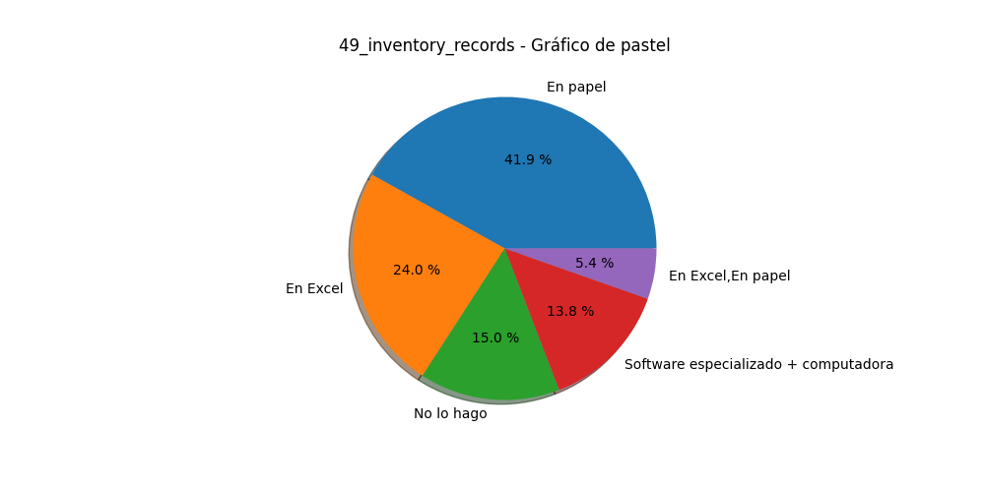

# Análisis para la variable categórica: 18_sales_records

|  |  |  |
| --- | --- | --- |
| Categoría | Frecuencia | Porcentaje |
| 79.0 | 0.4619883040935672 | 0.46198830409356745 |
| 26.0 | 0.15204678362573099 | 0.6140350877192984 |
| 24.0 | 0.14035087719298245 | 0.7543859649122809 |
| 18.0 | 0.10526315789473684 | 0.8596491228070178 |
| 6.0 | 0.03508771929824561 | 0.8947368421052635 |
| 6.0 | 0.03508771929824561 | 0.9298245614035091 |
| 4.0 | 0.023391812865497075 | 0.9532163742690062 |

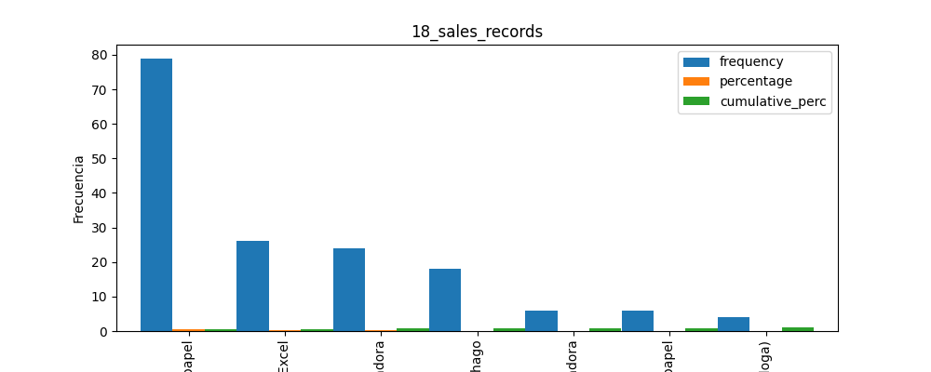

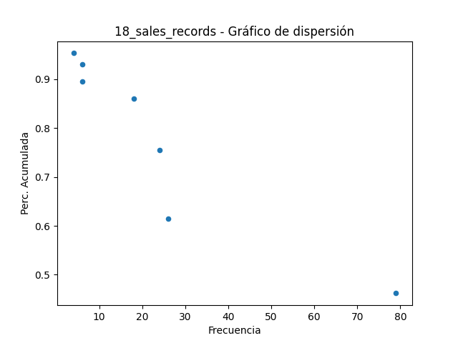

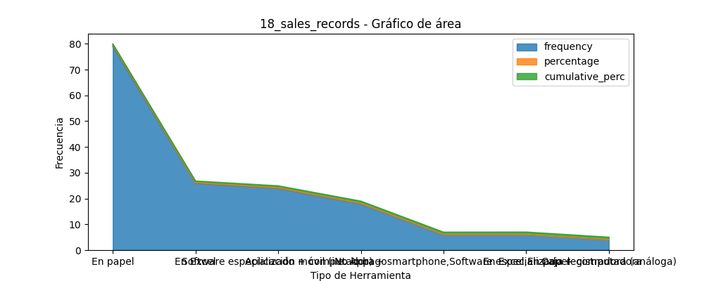

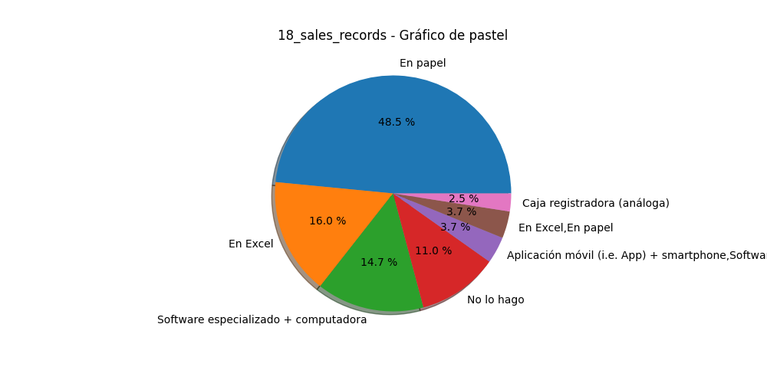

# Análisis para la variable categórica: 19_tax_id

|  |  |  |
| --- | --- | --- |
| Categoría | Frecuencia | Porcentaje |
| 132.0 | 0.7719298245614035 | 0.7719298245614035 |
| 39.0 | 0.22807017543859648 | 1.0 |

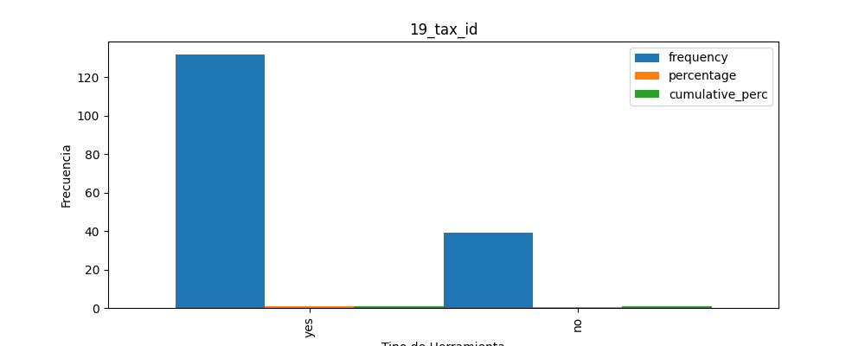

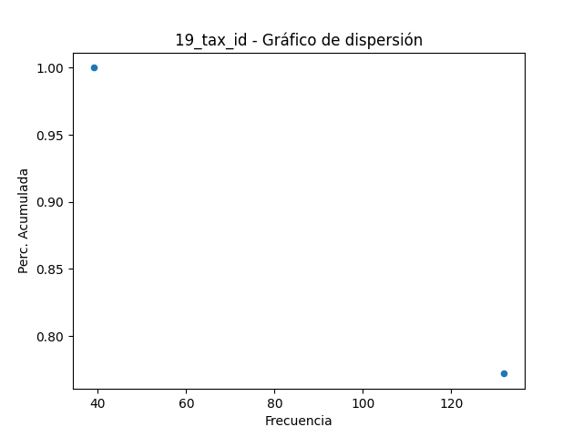

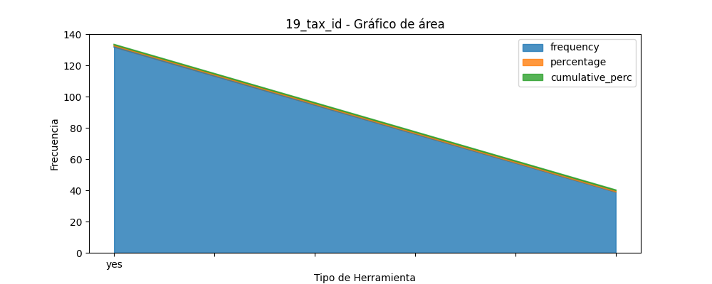

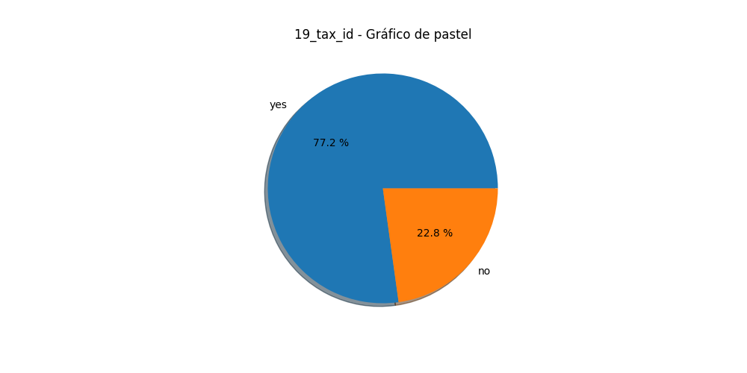

# Análisis para la variable categórica: 310_burnout

|  |  |  |
| --- | --- | --- |
| Categoría | Frecuencia | Porcentaje |
| 99.0 | 0.5789473684210527 | 0.5789473684210527 |
| 72.0 | 0.42105263157894735 | 1.0 |

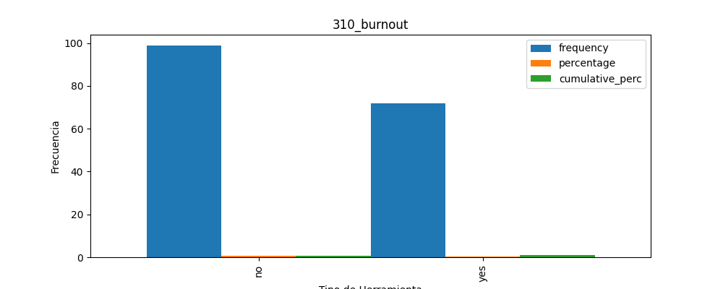

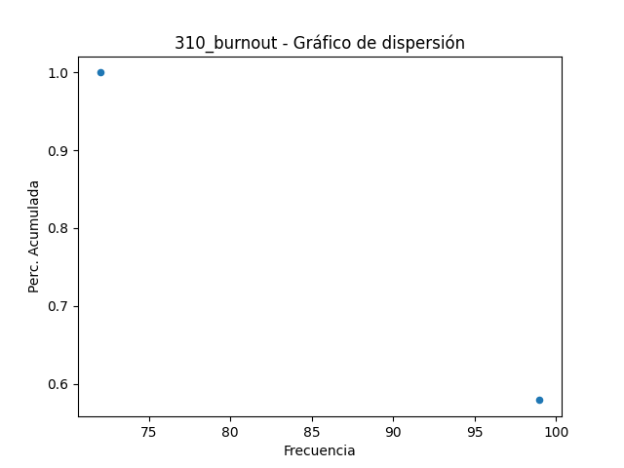

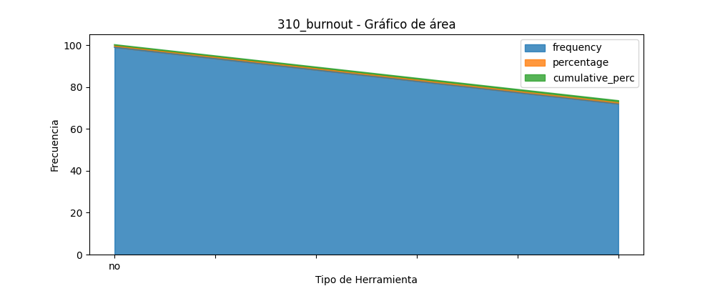

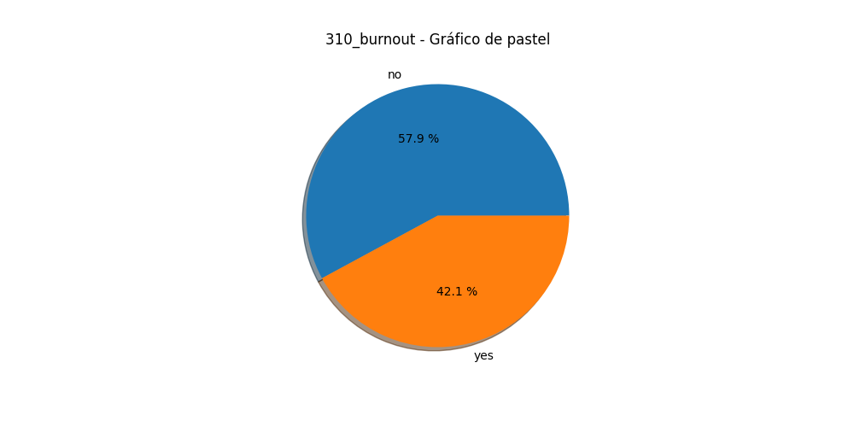

# Análisis para la variable categórica: 186_internet_connection

|  |  |  |
| --- | --- | --- |
| Categoría | Frecuencia | Porcentaje |
| 123.0 | 0.7192982456140351 | 0.7192982456140351 |
| 48.0 | 0.2807017543859649 | 1.0 |

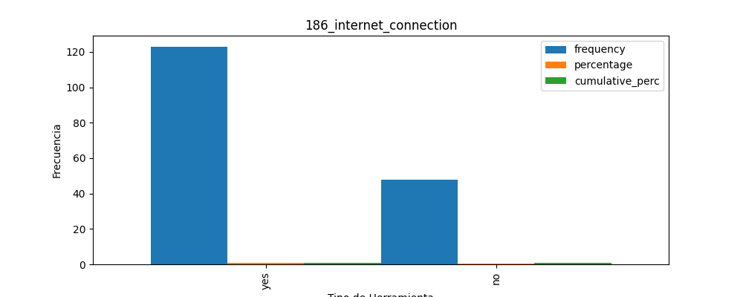

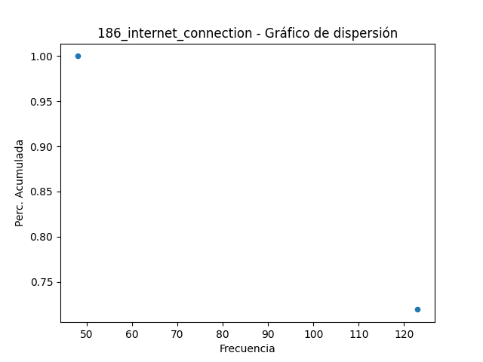

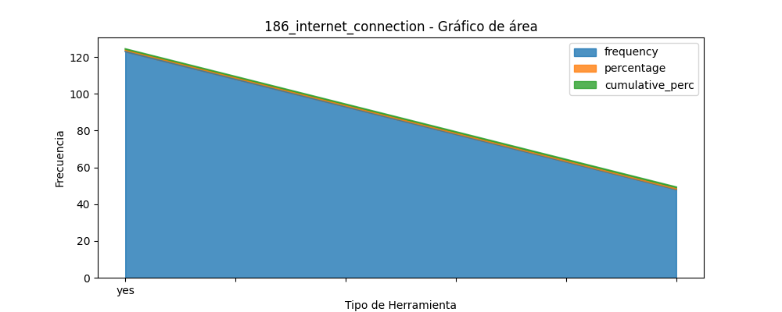

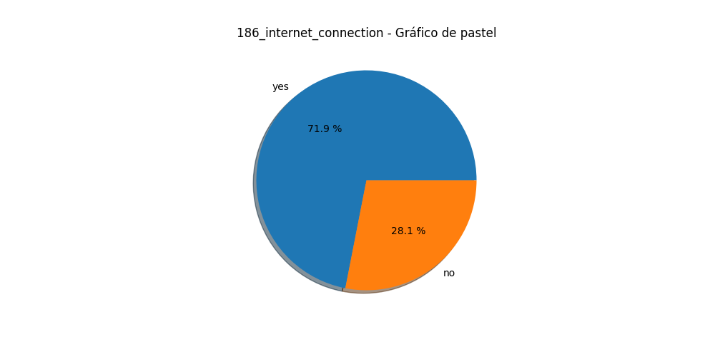

# Análisis para la variable categórica: 189_payment_methods

|  |  |  |
| --- | --- | --- |
| Categoría | Frecuencia | Porcentaje |
| 83.0 | 0.4853801169590643 | 0.4853801169590644 |
| 37.0 | 0.21637426900584794 | 0.7017543859649124 |
| 29.0 | 0.1695906432748538 | 0.8713450292397662 |
| 18.0 | 0.10526315789473684 | 0.976608187134503 |
| 2.0 | 0.011695906432748537 | 0.9883040935672516 |

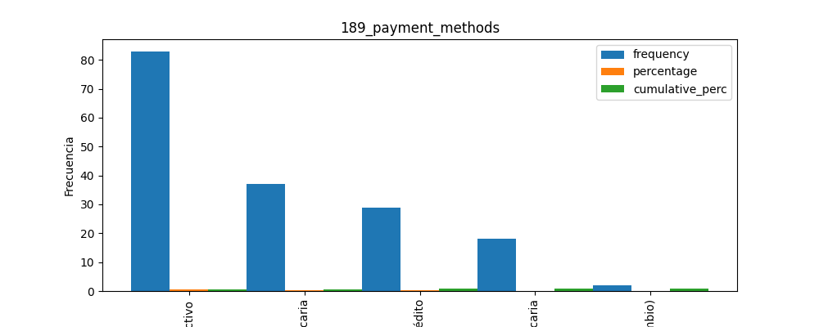

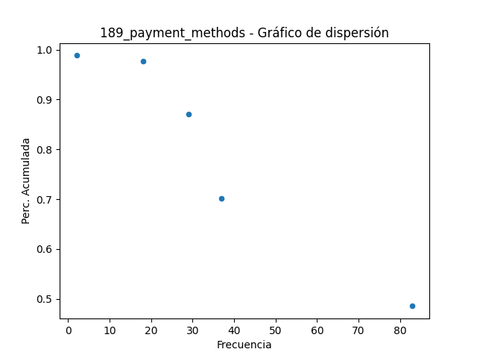

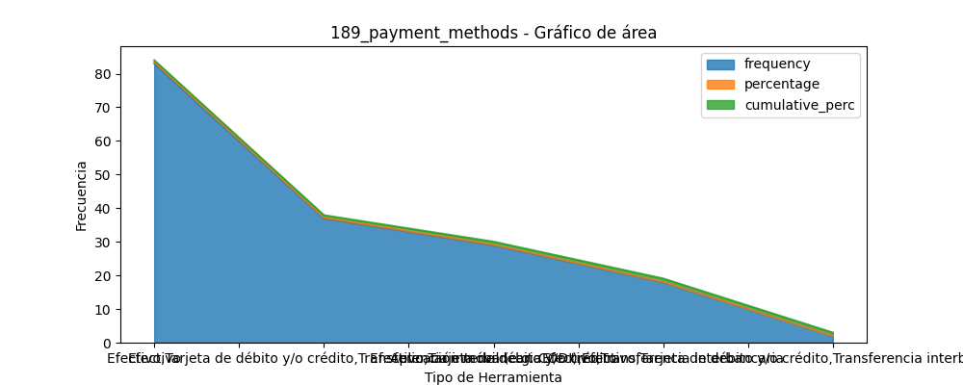

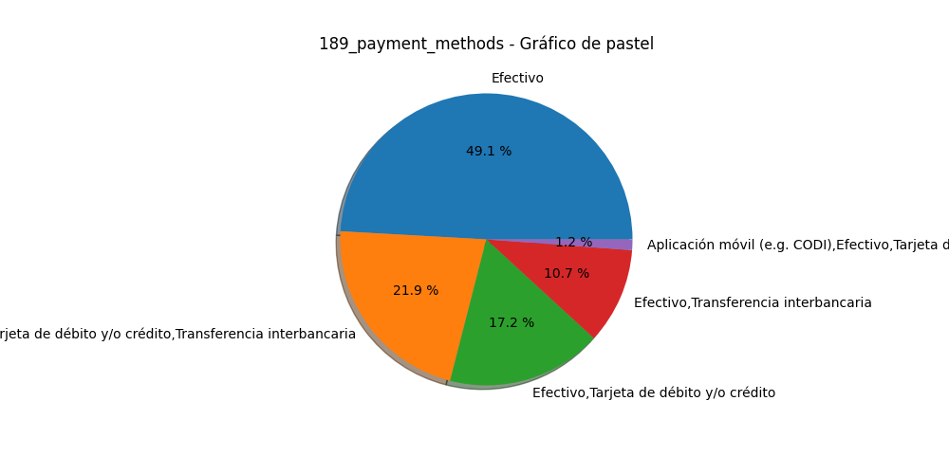

# Análisis para la variable categórica: 214_customer_relationship_tools

|  |  |  |
| --- | --- | --- |
| Categoría | Frecuencia | Porcentaje |
| 57.0 | 0.3333333333333333 | 0.33333333333333337 |
| 36.0 | 0.21052631578947367 | 0.543859649122807 |
| 30.0 | 0.17543859649122806 | 0.7192982456140351 |
| 21.0 | 0.12280701754385964 | 0.8421052631578949 |
| 18.0 | 0.10526315789473684 | 0.9473684210526317 |
| 2.0 | 0.011695906432748537 | 0.9590643274853803 |

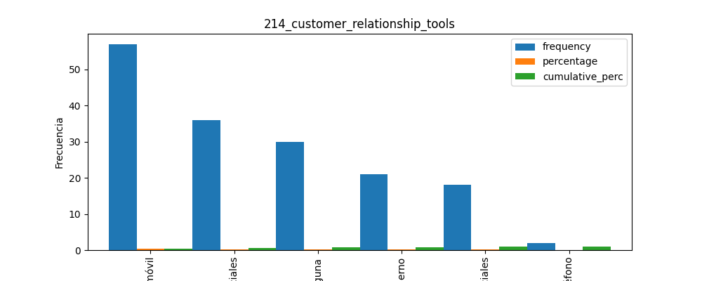

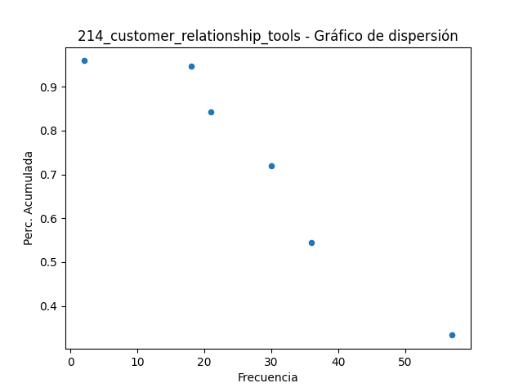

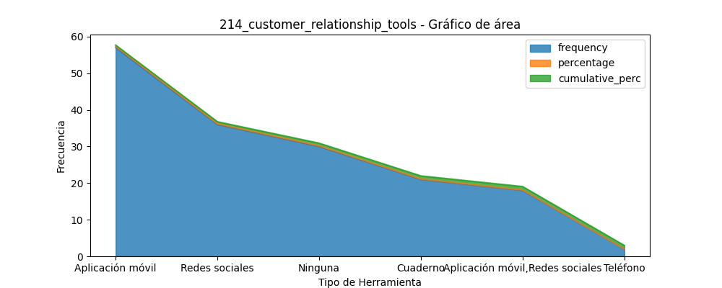

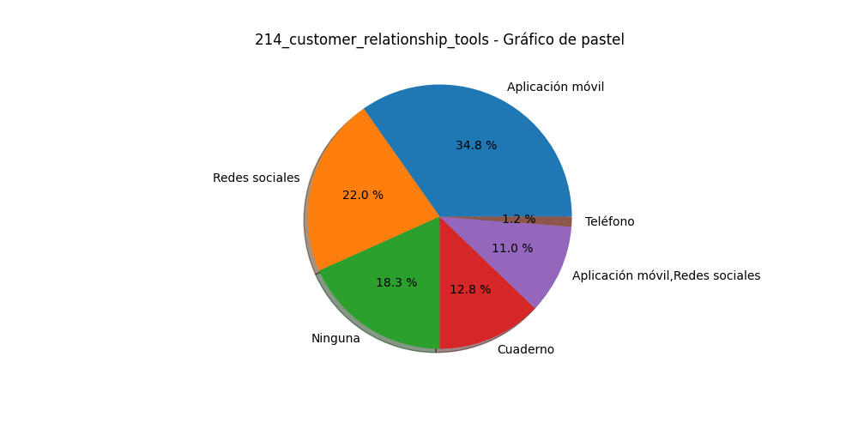

# Análisis para la variable categórica: 33_credit_to_customers

|  |  |  |
| --- | --- | --- |
| Categoría | Frecuencia | Porcentaje |
| 132.0 | 0.7719298245614035 | 0.7719298245614035 |
| 39.0 | 0.22807017543859648 | 1.0 |

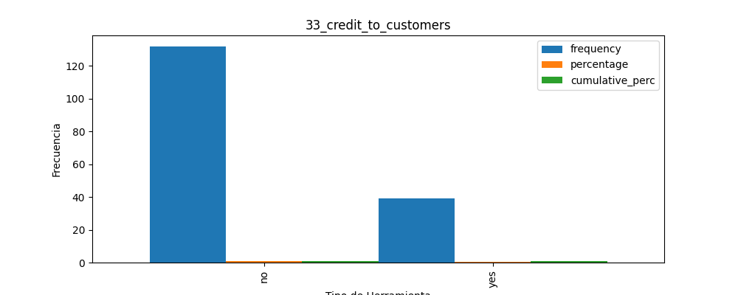

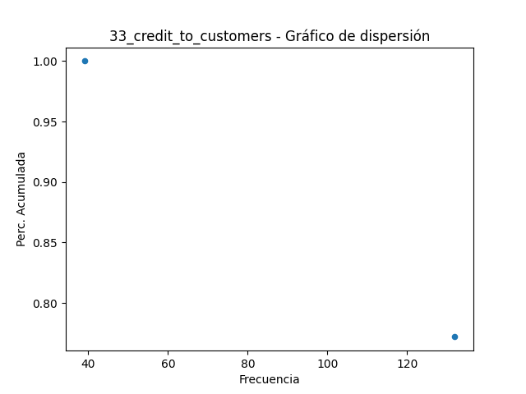

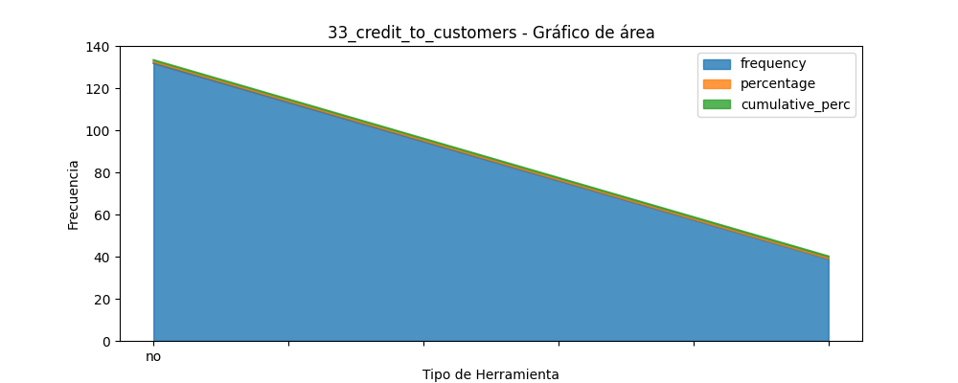

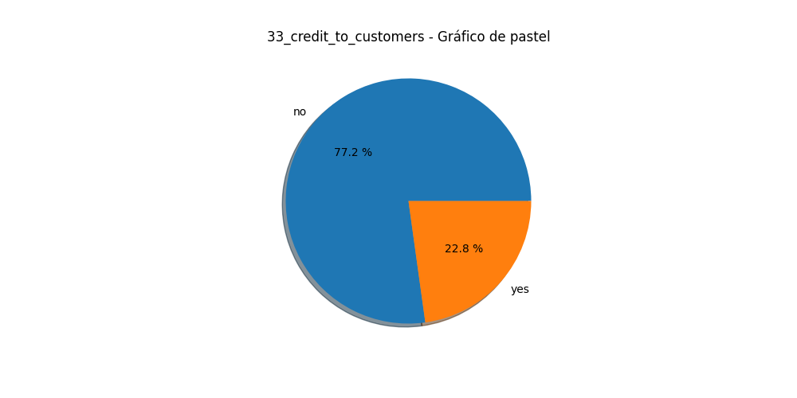

# Análisis para la variable categórica: 227_agreement_ecommerce_platforms

|  |  |  |
| --- | --- | --- |
| Categoría | Frecuencia | Porcentaje |
| 154.0 | 0.9005847953216374 | 0.9005847953216374 |
| 17.0 | 0.09941520467836257 | 1.0 |

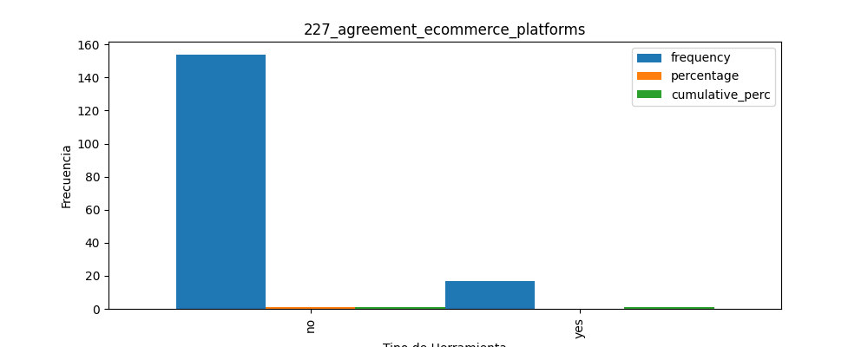

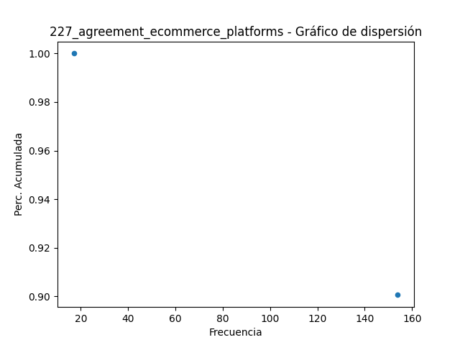

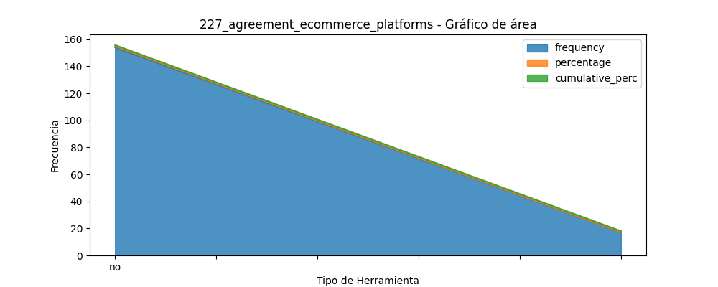

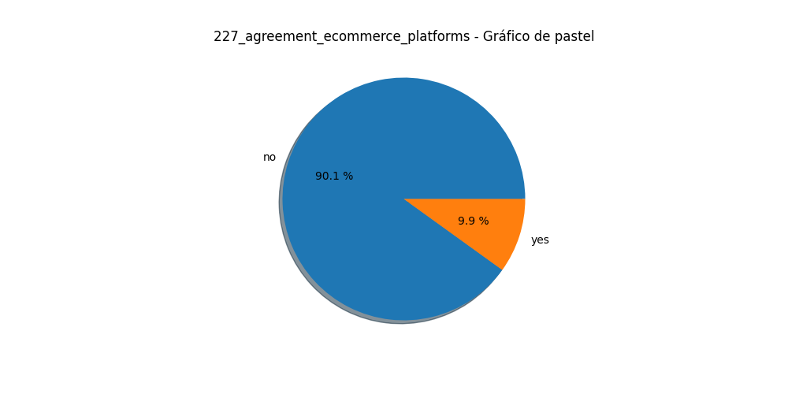

# Análisis para la variable categórica: 157_frequency_organize_shelves

|  |  |  |
| --- | --- | --- |
| Categoría | Frecuencia | Porcentaje |
| 92.0 | 0.5380116959064327 | 0.5380116959064328 |
| 49.0 | 0.28654970760233917 | 0.8245614035087719 |
| 12.0 | 0.07017543859649122 | 0.8947368421052632 |
| 8.0 | 0.04678362573099415 | 0.9415204678362573 |
| 5.0 | 0.029239766081871343 | 0.9707602339181286 |
| 2.0 | 0.011695906432748537 | 0.9824561403508771 |
| 2.0 | 0.011695906432748537 | 0.9941520467836257 |

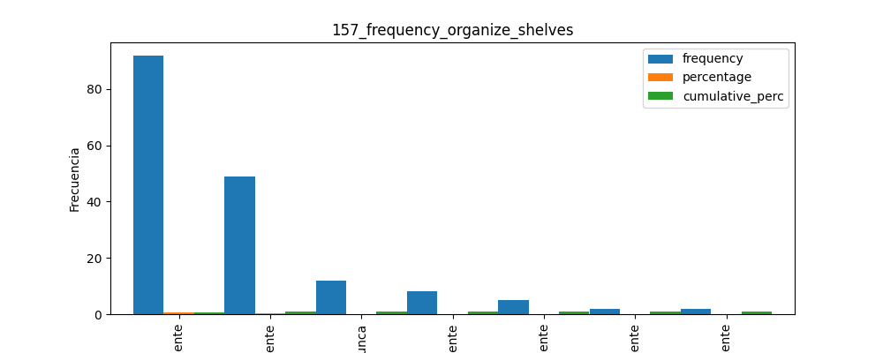

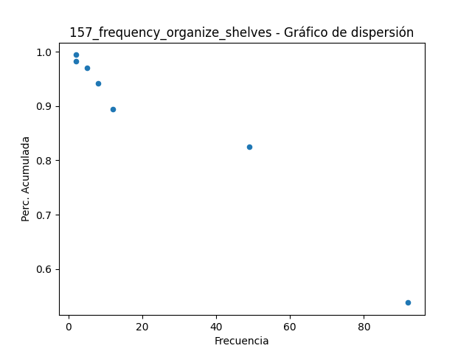

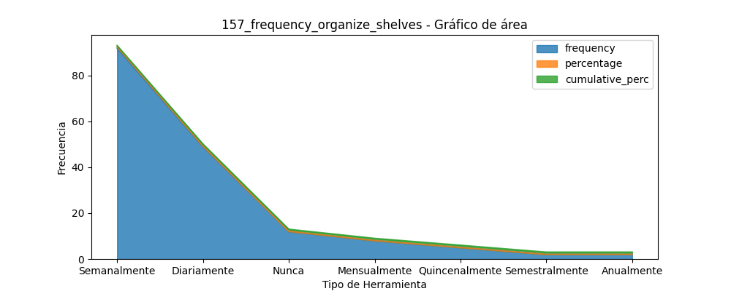

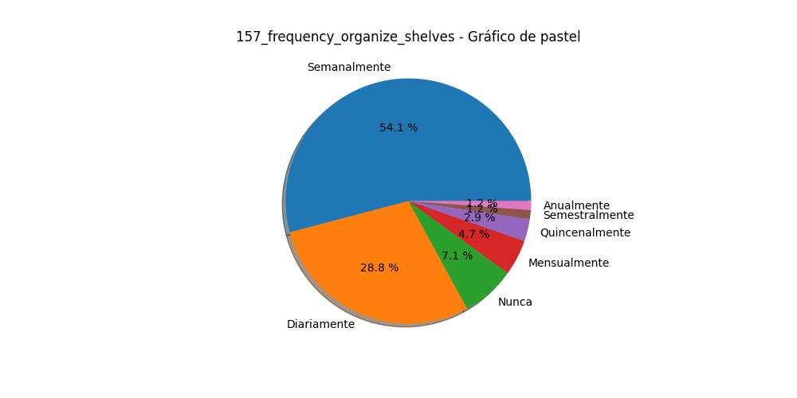

# Análisis para la variable categórica: 158_charact_organize_products_on_shelves

|  |  |  |
| --- | --- | --- |
| Categoría | Frecuencia | Porcentaje |
| 63.0 | 0.3684210526315789 | 0.368421052631579 |
| 33.0 | 0.19298245614035087 | 0.5614035087719299 |
| 15.0 | 0.08771929824561403 | 0.649122807017544 |
| 10.0 | 0.05847953216374269 | 0.7076023391812867 |
| 9.0 | 0.05263157894736842 | 0.7602339181286553 |
| 8.0 | 0.04678362573099415 | 0.8070175438596494 |
| 7.0 | 0.04093567251461988 | 0.8479532163742693 |
| 4.0 | 0.023391812865497075 | 0.8713450292397664 |
| 4.0 | 0.023391812865497075 | 0.8947368421052635 |
| 3.0 | 0.017543859649122806 | 0.9122807017543864 |
| 3.0 | 0.017543859649122806 | 0.9298245614035092 |
| 2.0 | 0.011695906432748537 | 0.9415204678362578 |
| 2.0 | 0.011695906432748537 | 0.9532163742690063 |

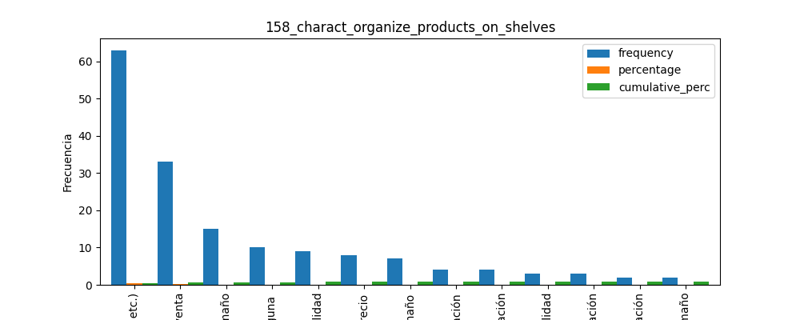

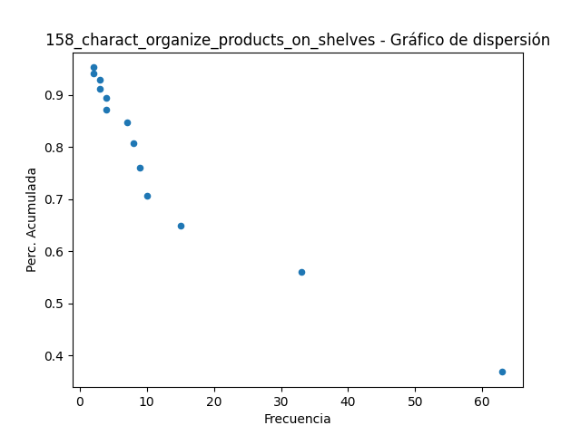

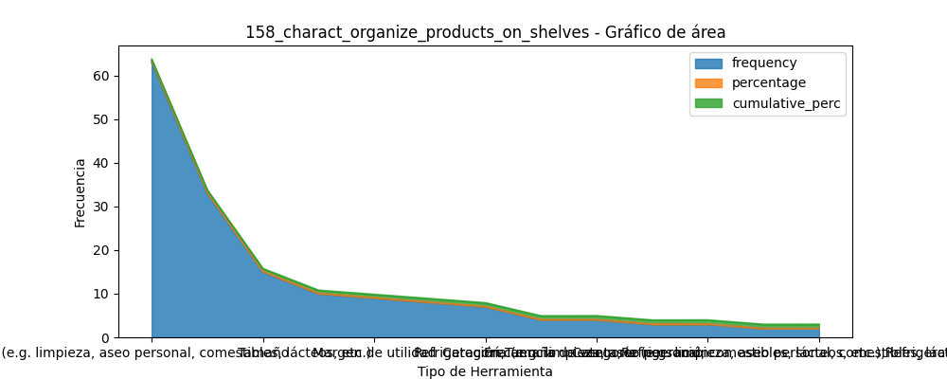

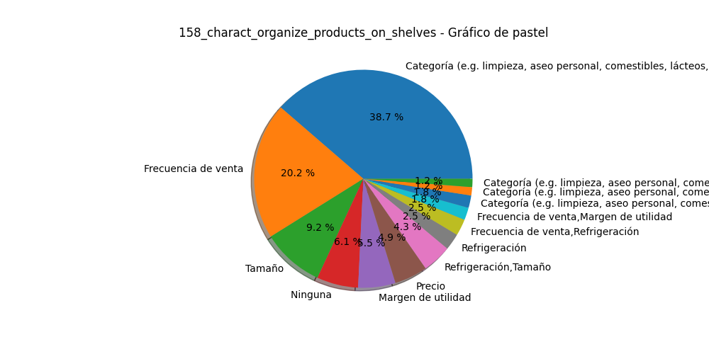

# Análisis para la variable categórica: 161_actions_stockouts

|  |  |  |
| --- | --- | --- |
| Categoría | Frecuencia | Porcentaje |
| 76.0 | 0.4444444444444444 | 0.44444444444444453 |
| 24.0 | 0.14035087719298245 | 0.584795321637427 |
| 23.0 | 0.13450292397660818 | 0.7192982456140352 |
| 19.0 | 0.1111111111111111 | 0.8304093567251465 |
| 10.0 | 0.05847953216374269 | 0.8888888888888892 |
| 5.0 | 0.029239766081871343 | 0.9181286549707606 |
| 4.0 | 0.023391812865497075 | 0.9415204678362576 |
| 3.0 | 0.017543859649122806 | 0.9590643274853805 |
| 2.0 | 0.011695906432748537 | 0.970760233918129 |
| 2.0 | 0.011695906432748537 | 0.9824561403508776 |

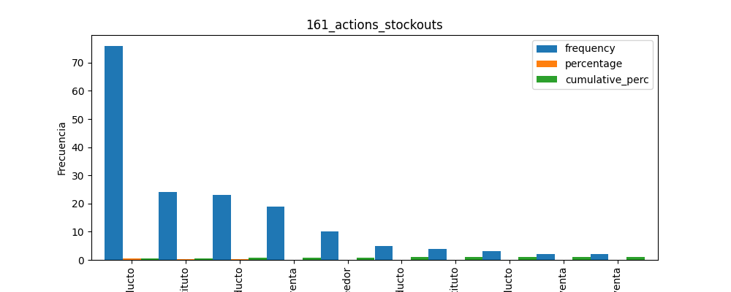

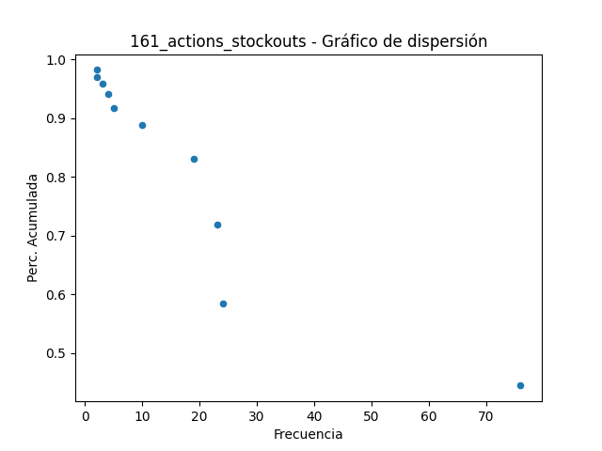

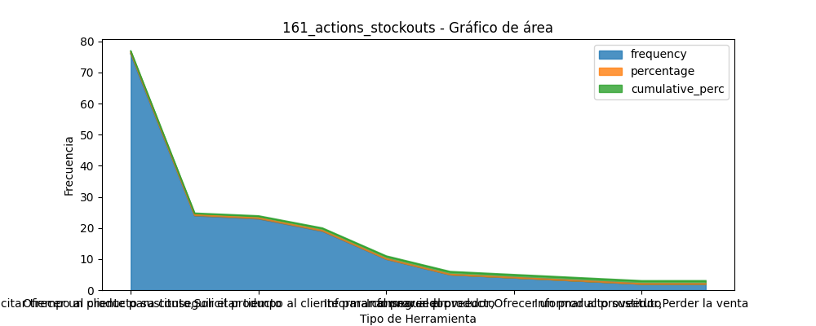

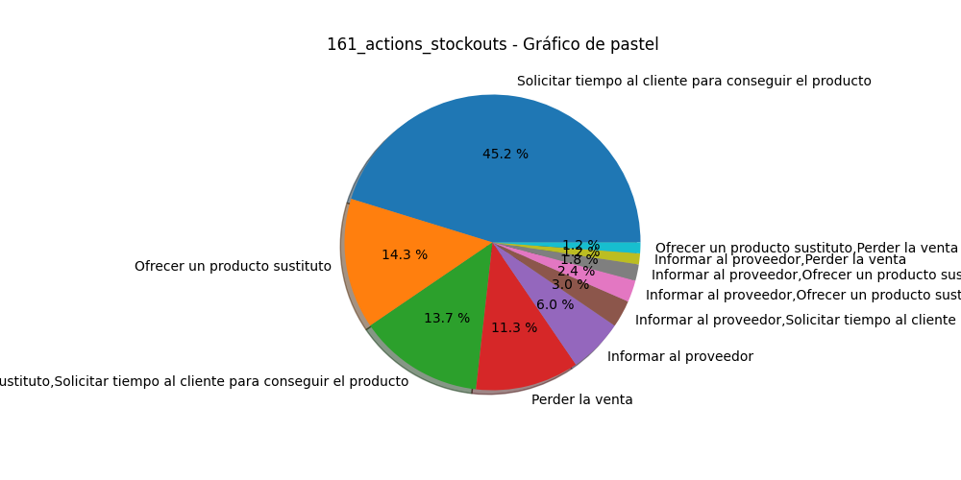

# Análisis para la variable categórica: 162_inventory_extra_space

|  |  |  |
| --- | --- | --- |
| Categoría | Frecuencia | Porcentaje |
| 83.0 | 0.4853801169590643 | 0.4853801169590643 |
| 23.0 | 0.13450292397660818 | 0.6198830409356725 |
| 22.0 | 0.1286549707602339 | 0.7485380116959064 |
| 16.0 | 0.0935672514619883 | 0.8421052631578947 |
| 12.0 | 0.07017543859649122 | 0.9122807017543859 |
| 10.0 | 0.05847953216374269 | 0.9707602339181286 |
| 5.0 | 0.029239766081871343 | 1.0 |

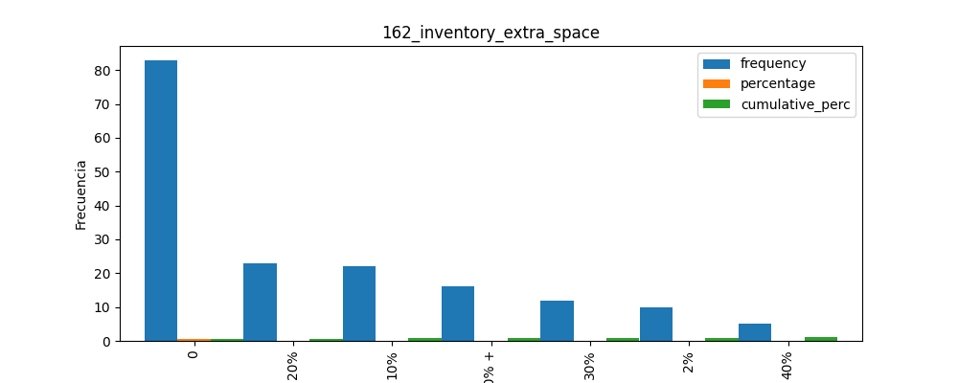

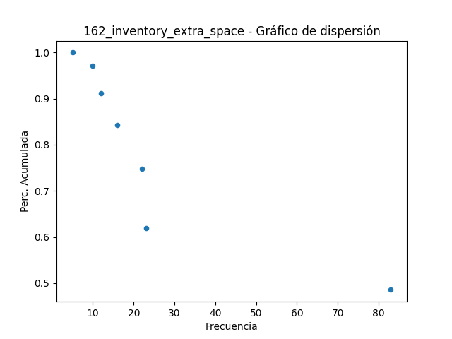

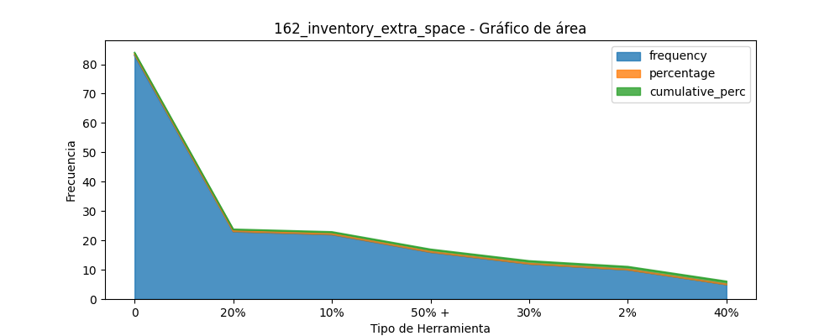

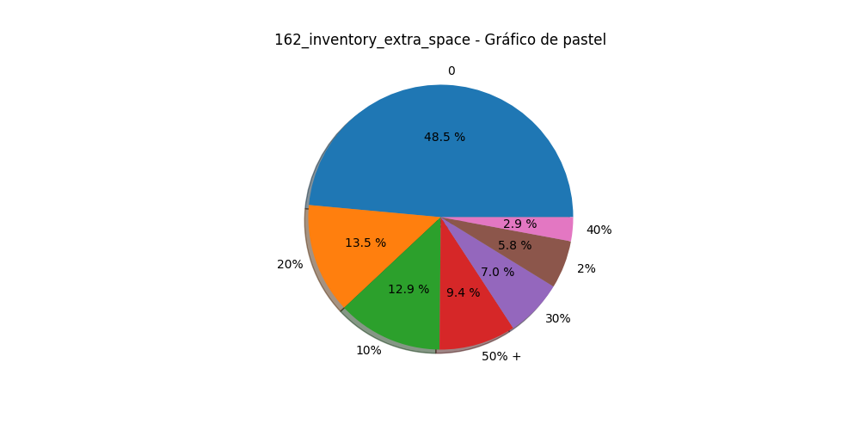

# Análisis para la variable categórica: 234_willingness_participate_workshop

|  |  |  |
| --- | --- | --- |
| Categoría | Frecuencia | Porcentaje |
| 99.0 | 0.5789473684210527 | 0.5789473684210527 |
| 72.0 | 0.42105263157894735 | 1.0 |

